Prompt (1.1):
I have attached a user store which contains complete details about the system to be developed. I want you to extract all the functional and non-functional requirements. The output should be easy to understand, traceable, well-defined, and in the standard format.

Summary:
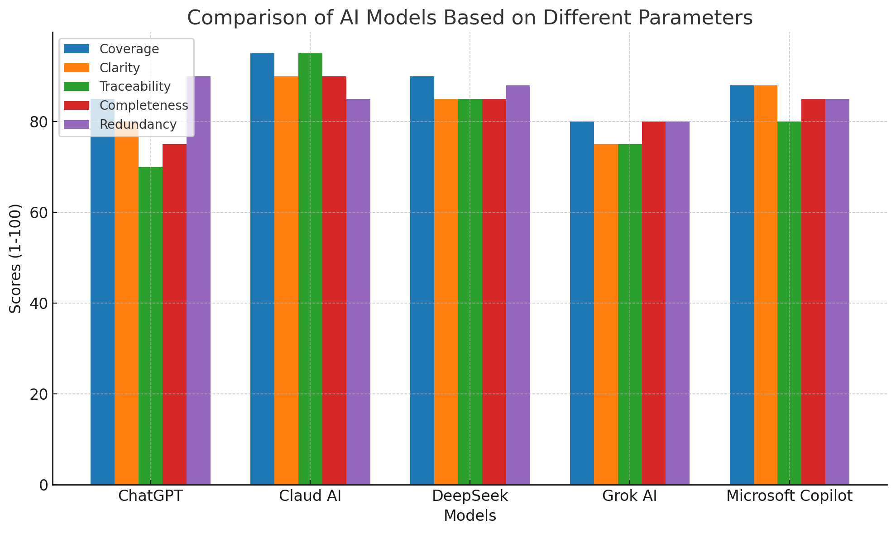
Evaluation Criteria & Scoring Methodology
- Coverage (Extent to which all functional/non-functional requirements are captured)
- Clarity (Precision, readability, and organization of requirements)
- Traceability (Linkage to original SRS sections/justifications)
- Completeness (Inclusion of all critical details like actors, priorities, and purposes)
- Redundancy (Avoidance of duplicate or overly repetitive requirements)

Scores (1–100)
Model | Coverage | Clarity | Traceability | Completeness | Redundancy
ChatGPT | 85 | 80 | 70 | 75 | 90
Claud AI | 95 | 90 | 95 | 90 | 85
DeepSeek | 90 | 85 | 85 | 85 | 88
Grok AI | 80 | 75 | 75 | 80 | 80
Microsoft Copilot | 88 | 88 | 80 | 85 | 85

Key Findings
- Coverage
  - Claud AI (95) and DeepSeek (90) captured the most requirements, including niche features like lab result interpretation and staff lifecycle management.
  - ChatGPT (85) and Grok AI (80) missed finer details (e.g., multi-channel communication in NFRs).
- Clarity
  - Claud AI (90) and Microsoft Copilot (88) used structured formats (e.g., priority labels, measurement criteria).
  - Grok AI (75) had less organized bullet points.
- Traceability
  - Claud AI (95) explicitly linked requirements to SRS sections (e.g., "Page 1, Patient Registration").
  - ChatGPT (70) lacked traceability markers.
- Completeness
  - Claud AI (90) included actors, priorities, and purposes for each requirement.
  - DeepSeek (85) missed some non-functional details (e.g., backup procedures).
- Redundancy
  - All models scored well (80+), with ChatGPT (90) being the most concise.

Recommendations
- Best Overall: Claud AI for comprehensive, traceable, and well-structured output.
- Balanced Option: Microsoft Copilot for clarity and usability.
- Avoid: Grok AI for lower coverage and clarity.

